**(PUSL 2021) Computing Group Project**

Project Proposal Documentation

**Online Auction Application**

**Group Members:**

**Group No 12**

|  |  |
| --- | --- |
| **Use name** | **Plymouth Id** |
| Siddanth AANK | Siddanth |
| Manudi wijesekara | 10898947 |
| Akila Vidusha | 10898947 |
| Chamitha Pehesara | Pehesara |
| Kaveesha Umayangani | 10898930 |
| P C Dilshan Fernando | 10899404 |

**Project overview and introduction**

**Introduction:**

* Through this disease of ours, people get the right to sell the goods with the right value for the goods they have and in certain cases, the value and demand for certain goods increases in certain times, so those who want to decide how much the goods are worth to them through this website. And he can set a price for the goods to that seller.
* In today's world, more and more people are using the internet, and what they really want is an easy-to-use and secure online auction site. Our project, Online Auction Application, is built to do just that.
* We want to make a modern, simple, and safe website where different people can buy and sell things. This site is great for individual sellers, companies, collectors, and anyone who wants to find good deals and sell things online. At a time when people want things to be easy and full of opportunities, our app will be the best place to buy and sell all kinds of products.

**Project Purpose:**

The purpose of this project is to provide a robust and reliable online auction platform that revolutionizes the way people trade goods online. With the global shift towards e-commerce and online marketplaces, our application seeks to address the evolving needs of consumers and sellers by offering a secure, user-friendly, and feature-rich environment for online bidding and trading.

**Objectives of the Project**

* Develop a responsive and intuitive website and mobile app.
* Attract and retain a substantial user base, comprising sellers and buyers.
* Ensure the highest standards of security, privacy, and trust for our users.
* Enable a diverse range of product listings, from everyday items to unique collectibles.
* Build a profitable and sustainable platform that brings value to all stakeholders.

**Target Users**

* Sometimes people cannot imagine the true value of the item or equipment they have. Then sometimes it can be sold for fair value or unfair value. It can be disadvantageous for both the seller and the customer.
* In such cases, the user can get a better value for his/her item or device through the user auction system through this website.
* The target audience for our online auction application is diverse, encompassing individuals, collectors, businesses, and bargain hunters. Our platform caters to those seeking a wide array of products, including antiques, electronics, fashion, art, and more. With a user-friendly interface and robust security measures, our application appeals to both novice and experienced sellers and buyers.
* We aim to create a welcoming and inclusive marketplace, offering a seamless and secure experience for users of all backgrounds, preferences, and interests.

**Propose Technologies and Tools**

* We create an account for our users on our web site and take necessary steps to keep that data safe in a database, and if necessary, the user can link his bank accounts or cards to his account.
* We Use Python or Ruby on Rails for the behind-the-scenes work. Keep your data safe with databases like PostgreSQL or MySQL.
* For payments, use Stripe to keep transactions safe. Tools like Git and Jenkins help with keeping the app running smoothly. To keep things secure, use tech like SSL, OAuth, and multi-factor authentication.

**Project Development Timeline**

Our project development process includes the following steps.

1. Project Initiation
2. Requirement Gathering
3. System Design
4. Database Setup
5. Frontend Design
6. Frontend Development
7. Backend Design
8. Backend Development
9. Testing and QA
10. Bug Fixing and Refinement
11. Deployment and Launch
12. Project Completion

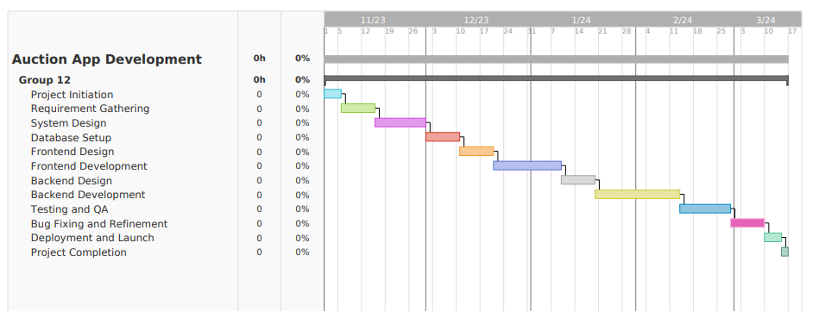**Timeline**